University of Central Punjab
Faculty of Information Technology and Computer Science

Course Title: Digital Logic and Design
Course Code: AR102

Assignment 2 Solution

Problem 1 Marks:10
Consider the combinational circuit shown in figure below;
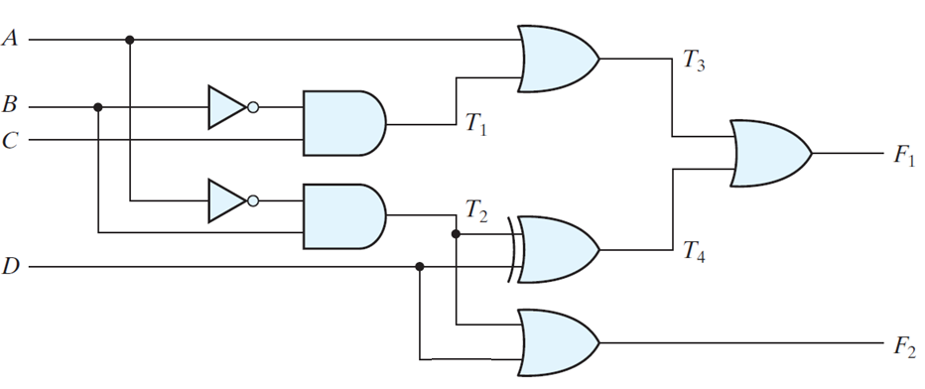
Analyze the given 2-output logic system. Write and simplify Boolean expressions for each output, derive the truth table, and demonstrate how the system behaves.

Solution:

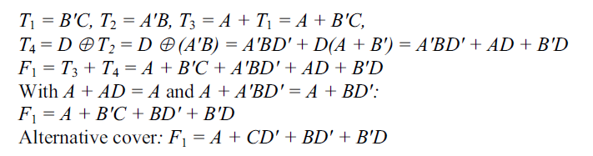

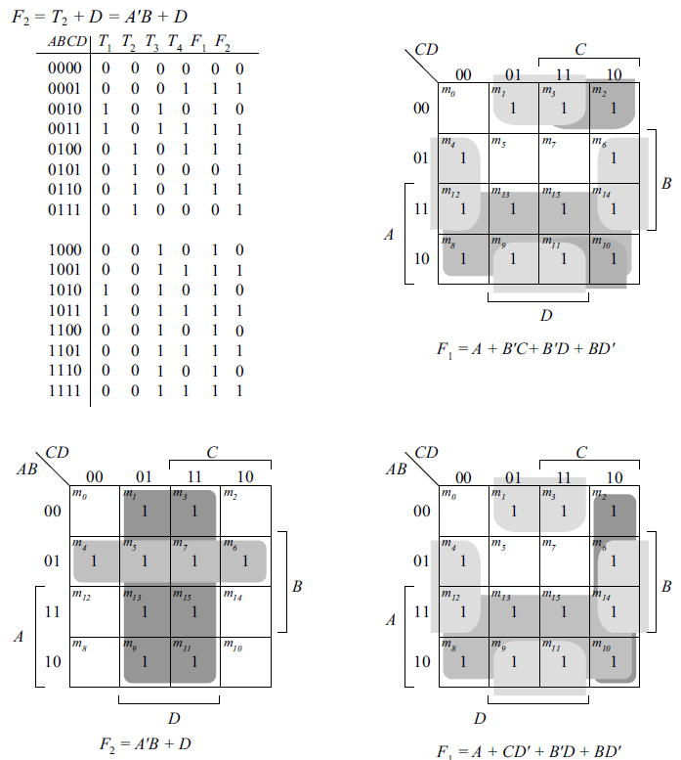

Problem 2 ____ Marks: 10
A combinational circuit is specified by the following three Boolean functions:

F₁(A, B, C) = ∑ (2, 4, 7)
F₂(A, B, C) = ∑ (0, 3)
F₃(A, B, C) = ∑ (0, 2, 3, 4, 7)

Implement the circuit with a decoder constructed with NAND gates (similar to Fig. 4.19 of Moris Mono Book) and NAND or AND gates connected to the decoder outputs. Use a block diagram for the decoder. Minimize the number of inputs in the external gates.

Solution:

